Feature Image content: "Style Your Suit Perfectly—Click for Tips!"

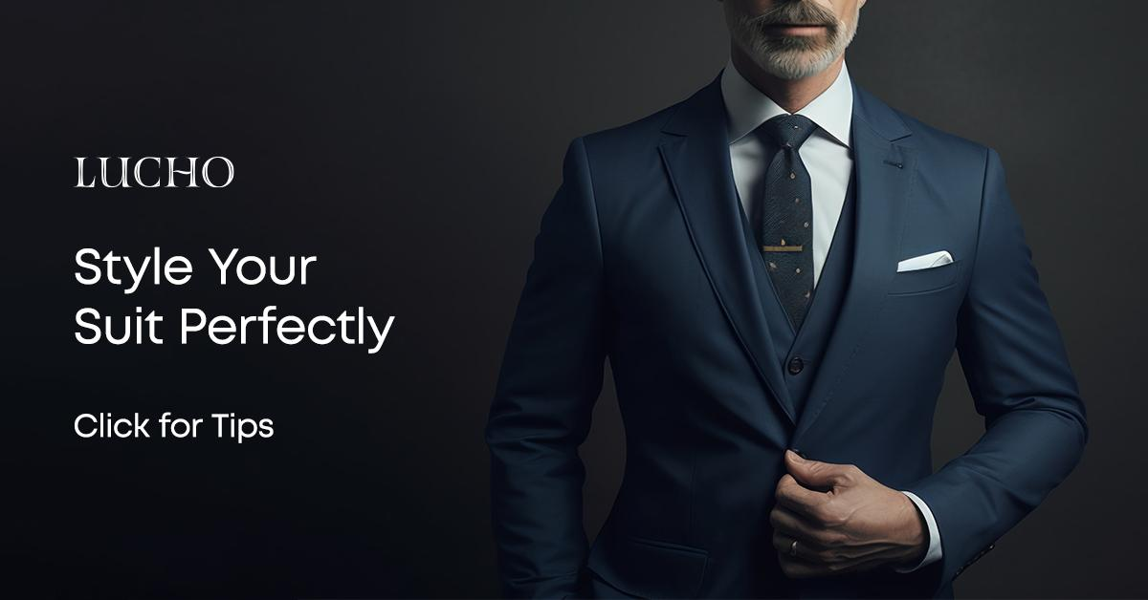
Title: How to Style Your Premium Custom Suit for Any Occasion

Focus keyword: Premium Custom Suits

Secondary Keywords:
Men custom suits in houston
custom clothing store in Houston
Men Custom Garments

Words count : 900 to 1000

Internal Links:
Custom Men Suit: https://lucho.com/for-men/
Men's suits: https://lucho.com/mens-suit/

Meta Description:
Master the art of styling your premium custom suit with Lucho. Learn how to dress impeccably for business, weddings, casual events & evening occasions.

How to Style Your Premium Custom Suit for Any Occasion H1
A suitable premium custom suit creates the strongest impact for any occasion. A custom suit works for all types of events because it shows style and elegance in a way that fits your special personality and appearance very well.
At Lucho, our experts develop high-quality custom suits to fit your specific body and depict your individual personality attributes. This extensive guide shows proper methods to dress your custom-made menswear suit regardless of the event. The solution enables you to maintain a flawless appearance in all circumstances.

Why Choose a Premium Custom Suit H2
Before diving into different styling tips, it’s important you should understand why you need to invest in a premium custom suit.
Is it really worth it?
In the case of Premium Custom Suits, you get the opportunity to take measurements in the perfect size that avoids discomfort.
You can select every detail including fabric choice, cloth color, lapel style and button type when you order a custom suit for yourself. If you are living in Houston then our men custom suits in Houston are perfect for your style and unique personality.

At Lucho, our custom clothing store in Houston, our experts design suits that perfectly match your style as well as fit your measurements or any other specific outfit requirements.

Styling Your Premium Custom Suit for Different Occasions H2

1. Business Meetings and Corporate Events H3
Professional business suits need to project authority through their design. When dressing for business events wear your premium custom suit according to these guidelines:
- Fabric and Color: Select fabrics made from wool or wool blends in colors navy, charcoal and gray to create a classic custom suit that fits professionally. These color options build enduring trust and power when worn.
- Fit: The suit needs a perfect fit to look contemporary and professional. A properly tailored jacket and pants convey a clean professional appearance.
- Shirt and Tie: Match your suit with firmly pressed white or delicate blue dress shirts. To complete your professional look get a silk tie in plain or faint print.
- Shoes: Choose Oxford or Derby shoes in black or brown leather. Finish your shoes with a high-quality shine as the last step in preparation.
- Accessories: A small leather belt and classic timepiece along with minimal cufflinks create an elegant statement without overwhelming.
Lucho provides Men Custom Garments with custom options that suit corporate settings through their different fabric and design choices.

2. Weddings and Formal Events H3
Formal weddings and events require an elegant and sophisticated suit style. Follow these steps to create a suitable men's custom suit look for official events
- Fabric and Color: Choose luxurious fabrics like velvet, silk, or fine wool. Moderate blue midnight or dark burgundy tones serve wedding necessities effectively.
- Fit: A slim-fitting and personalized suit compliments professional occasions because it highlights your body shape and gives you a contemporary appearance.
- Shirt and Tie: A white dress shirt remains the standard yet lighter shirt tones are suitable for testing new styles. If you want a stylish outfit just match the bow tie or necktie.
- Shoes: Opt for patent leather shoes in black or oxblood for a formal touch.
- Accessories: A pocket square cutlery set and boutonniere help you achieve a more sophisticated appearance.
Our bespoke suit services in Houston assist customers in creating their ideal suit for all their formal social events.

3. Casual Gatherings and Social Events H3
A premium custom suit works effectively for all types of informal events. Your outfit needs to maintain a relaxed yet fashionable appearance.
- Fabric and Color: Select linen or cotton materials for your suit when attending casual events. Choose pastel and light hues including beige and pale gray.
- Fit: A suit that fits a bit loosely will be more comfortable while looking casual. Pick a single-breasted jacket with pockets for a partial breast design and a relaxed fit.
- Shirt: Instead of wearing a necktie go with a casual shirt style including button-down or polo versions. Pull your sleeve to lower the dress code.
- Shoes: Casual events call for shoes designed as loafers or suede derby styles.
- Accessories: A leather bracelet accompanied by a fashionable watch enables people to display their individual fashion sense.
Lucho enables customers to select clothing items that transition easily between formal and informal dress occasions.

4. Cocktail Parties and Evening Events H3
Dining parties need attire that combines smartness with style in the setting. Here’s how to nail the look:
- Fabric and Color: Choose dark and luxurious tone options including black, deep green, and navy for your outfit. Satin and silk mix fabrics create an excellent option due to their sheen effect.
- Fit: A slender suit with peak lapels presents a premium appearance.
- Shirt and Tie: You should wear a black or white dress shirt combined with a thin tie or bow tie for your events.
- Shoes: You need black leather oxfords or monk straps to look suits for events in the evening.
- Accessories: A small selection of accessories such as watch, pocket squares and lapel pins will polish off your ensemble.

Tips for Maintaining Your Premium Custom Suit H2
To ensure your custom men suit stays in pristine condition, here are some tips you need to follow:
- Rotate Your Suits: Change your suits each day so they can properly regain shape. Let the piece fully stretch and recover to its normal shape.
- Use a Wooden Hanger: Place your suit on a wood frame to keep it looking its best.
- Dry Clean Sparingly: Regular over-drying during cleaning can cause fabric damage. Only dry clean when necessary.
- Brush Regularly: A suit brush should be your go-to tool to brush off dust and dirt each time you wear your suit.
- Steam, Don’t Iron: A steamer smooths wrinkles better than ironing because it reduces fabric damage.

Why Choose Lucho for Your Premium Custom Suits? H2
Our customers in Houston choose Lucho as their top custom clothing destination to find perfect suits for men. Our professional tailor specialists partner with you through the design process to produce a suit that matches your physique and personal trend. We design men's suits for all special occasions including weddings and business occasions plus informal events.
Our process is simple:
- Consultation: The consultation phase starts by discussing your needs and fashion choices through comprehensive client meetings.
- Fabric Selection: The selection process includes various premium fabrics for customers to choose from.
- Measurement: The designer team will make alterations according to the preferences for lapel design and button styles.
- Fitting and Adjustments: Our team performs various fits to guarantee your suit fits perfectly.

Conclusion H3
A premium custom suit represents your distinctive personal style and individuality through fashion. You can make a significant impact at any event by choosing the ideal suit. We support our customers in creating menswear suits exclusively for their personal requirements at Lucho.

Stop by our Houston store now to feel the quality of our made-to-order suits. At Lucho, you can find imagery appropriate for every social setting.
A premium custom suit combined with these suggestions will make you both look and feel confident in every situation. Collaborate with Lucho to build a wearable outfit selection designed for your personal approach to fashion.
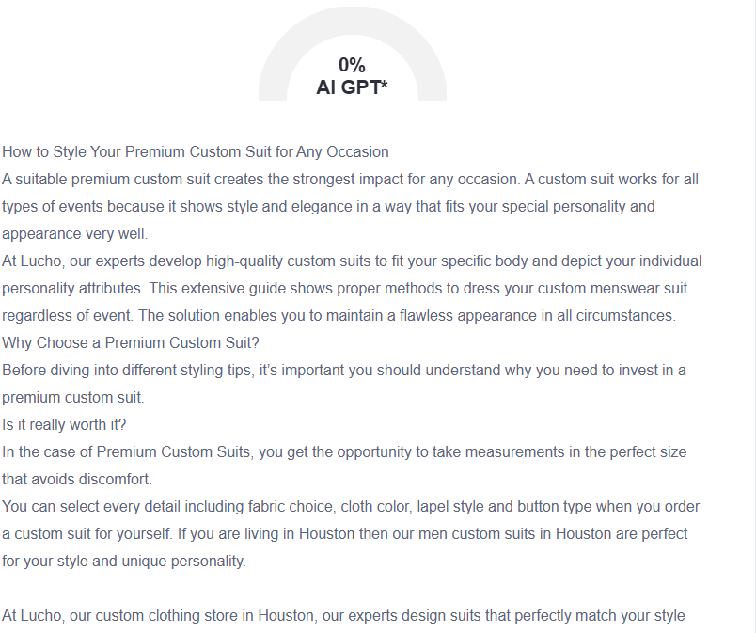

GMB
Experience the art of bespoke tailoring at Lucho, Houston's premier custom suit destination. The master tailors at Lucho produce premium custom suits which deliver perfect expressions of your personal style and individuality. Our experts assist customers in selecting fabrics and performing fittings for custom suits which serve all official business meetings and wedding events and everyday and evening occasions. Higher-end custom suits at Lucho deliver both exceptional craftsmanship and precise fit directions to make remarkable first impressions. Our suite of services consists of interacting meetings alongside precise measurements and careful analysis of lapels with button selections and accessory integration. Providing apparent information on how to care for your clothing is part of our service to ensure each investment stays formally perfect. At Lucho, we offer a wide variety of high-quality fabrics and customization choices which enable our customers to design garments that serve multiple event needs. Work with Lucho's skilled tailors who will create suits which align with your individual taste in addition to providing custom-fit dimensions. Our company dedicates itself to developing garments that enable both your confidence and elegance during any occasion starting from your first consultation up to your final fitting appointment. View our Houston store to experience our expert bespoke tailoring service which will upgrade your existing wardrobe.

